Humanitarian Crisis Support Spring 2020

Information and guidelines for applicants

Table of contents

1 HUMANITARIAN CRISIS SUPPORT, SPRING 2020 4

1.1 PURPOSE 4

1.2 AREAS OF SUPPORT 4

1.3 ELIGIBILITY 4

1.4 FUNDING 5

1.5 LANGUAGE 5

1.6 APPLICATION PROCESS 5

2 THE APPLICATION AND GRANT MANAGEMENT SYSTEM – NORMA 6

2.1 USER REGISTRATION 6

2.2 CREATING AN APPLICATION 7

2.3 TEXT AND ILLUSTRATIONS 7

2.4 SUBMITTING THE APPLICATION 8

3 APPLICATION CONTENT 9

3.1 APPLICANT INFORMATION 9

3.2 PROJECT INFORMATION 9

3.3 BUDGET 10

3.4 UPLOADS 11

3.5 PREVIOUS AND CURRENT GRANTS FROM NNF 11



Information about the call

Grant capital:

DKK 20 million

Award amount

Up to DKK 1,000,000.- per grant

Application form opens:

12 February 2020

Application deadline:

20 March 2020, 2 p.m.

Applicant notification:

June 2020

Earliest start date:

1 July 2020

Contact persons:

Anders Bager

Project Officer

Phone: 2523 1526

E-mail: [aba@novo.dk](mailto:aba@novo.dk)

Susanne Schou

Senior Administrator

Phone: 3527 6591

E-mail: ssch@novo.dk

# HUMANITARIAN CRISIS SUPPORT, SPRING 2020

These guidelines are intended to assist you in the application process when applying for a grant from the Novo Nordisk Foundation (NNF). It is important that you carefully read these guidelines before initiating the application process, as the guidelines contain the complete call text as well as instructions regarding the completion of the application.

NNF will treat all applicant and application information confidentially. Read more about how NNF processes personal data under ‘privacy & security’ in the online application system, NORMA. See how to access NORMA in section 2 of these guidelines.

Furthermore, please read ‘General Terms and Conditions’ for grants from NNF that all Grant Recipients must comply with: <http://www.novonordiskfonden.dk/en/content/conditions-grants>

## PURPOSE

With this open call for applications, the Novo Nordisk Foundation supports humanitarian crisis initiatives and actions targeting vulnerable populations affected by sudden onset and/or protracted humanitarian crises. The Humanitarian Crisis Support open call for applications is a biannual call (spring and fall).

## AREAS OF SUPPORT

The Humanitarian Crisis Support open call for applications is thematically and geographically unrestricted and applicants are encouraged to submit applications for projects that are within their area of expertise. Applications can cover all areas of humanitarian interventions incl. direct service delivery, rigid evaluations and pioneering approaches to financing initiatives.

A humanitarian crisis can be described as occurring ‘when the human, physical, economic or environmental damage from an event, or series of events, overwhelms a community’s capacity to cope’ (World Vision, 2018). Often associated as being the consequence of a singular, disastrous event such as an earthquake or hurricane, contemporary humanitarian crises are usually a consequence of conflict and state fragility that drives the most vulnerable populations to become displaced or in need of humanitarian aid (Humanitarian Policy Group, ODI, 2019).

The Novo Nordisk Foundation acknowledges that a humanitarian crisis can be sudden or slow onset and protracted, and that longer-term crises may comprise several humanitarian emergency situations.

The Novo Nordisk Foundation will rely on information from multiple international stakeholders and organisations and consult current inter-agency humanitarian appeals when assessing whether an application should be considered relevant in this category.

## ELIGIBILITY

Organisations and institutions with a registration in Denmark, specifically documented with a Danish CVR number, may apply for grants in the Humanitarian Crisis Support open call for applications.

The Novo Nordisk Foundation will only accept applications from internationally recognised and highly transparent organisations and institutions whose annual reports and annual audited financial reports are publicly available.

The Foundation also expects applicant organisations and institutions to have implemented a code of conduct by which they are guided and with which they comply in accordance with ethical and humanitarian guidelines and standards, e.g. the Core Humanitarian Standard on Quality and Accountability (CHS).

## FUNDING

Each application can request funding up to DKK 1 million for a project with a maximum duration of 1 year.

The project can be an independent, delimited project or part of a larger project that receives support from other sources.

If the applicant has applied for or been awarded co-funding from other sources, the applicant must always state this in the budget.

Administrative support can constitute up to 5% of the total grant. The amount(s) must be applied for and must be included in the grant budget. Administrative support can only be used for administrative expenses that are **directly related** to the implementation of the project.

**The administrative support:**

* can cover expenses such as accounting, controlling, auditing and reporting
* cannot cover ­administrative expenses that are not directly related to the project
* can via the host institution be shared between the institutions of the main- and co-applicant(s), as detailed in the application budget
* is not automatically included in the grant and must be stated/applied for in the application budget, but should not be specified in detail.

The Novo Nordisk Foundation does not support overhead expenses, i.e. expenses not directly related to and relevant to the project.

The grant may not be used to cover ’overhead’ (i.e. rent, electricity, water, maintenance etc.)



## LANGUAGE

The application and any additional uploads must be written in English.

## APPLICATION PROCESS

The application must be completed and submitted using NNF’s online application and grant management system, NORMA, which can be accessed from <https://norma.novonordiskfonden.dk/s_Login.jsp>

Please limit the number of appendixes to an absolute minimum.

Further information on how to access and navigate in NORMA can be found in chapter 2.

**20 March 2020, 2 p.m.**

Application deadline

**12 February 2020**

Call opens

**April / May 2020**

Evaluation of applications

**June 2020**

Applicant notification

**1 July 2020**

Earliest possible start date

When all applications have been assessed, applicants will be notified about whether or not they have been awarded a grant. The notification e-mail will be sent from [noreply@norma.novonordiskfonden.dk](mailto:noreply@norma.novonordiskfonden.dk) to the e-mail address entered on initial registration.

NNF does not provide feedback in case an application is

not selected for funding.



# THE APPLICATION AND GRANT MANAGEMENT SYSTEM – NORMA

Sections 2 and 3 provide guidance on completing and submitting an application through NNF’s online application and grant management system NORMA. Section 2 contains general technical information, while section 3 contains information specific to the individual call. All the fields of the application form must be completed in accordance with these guidelines and the instructions in NORMA.

## USER REGISTRATION

NORMA can be accessed through links on NNF’s website or directly at: <https://norma.novonordiskfonden.dk/s_Login.jsp>

Before you begin, please read the instructions on the login page.

If you do not have a user profile in NORMA, you can register by clicking on register as organisational applicant. You will be asked to fill in a contact form, which will appear in a new window. Main applicant should only have one user profile. Use your work e-mail address for registration. After the registration you will receive an e-mail with username and password. You can now log in to NORMA. When you log in for the first time, you will be asked to change your password.

Applicants who have previously applied for a grant from NNF or have an active grant may already have a user profile in NORMA. If you are in doubt, an existing user profile can be retrieved by clicking forgot password and entering an e-mail address. If you have a user profile in the system you will receive an e-mail with login information and a new password within 5–10 minutes.

A registered user that submits an application is legally responsible for the truthfulness of the content of the application.

If you experience technical problems, please contact NORMA Support: [norma-support@novo.dk](mailto:norma-support@novo.dk).

An applicant cannot change the e-mail address provided at registration. Please contact NORMA Support if you need to change your e-mail address.



## CREATING AN APPLICATION

To initiate a new application, you first need to identify the call and grant you wish to apply for. In NORMA, go to the open calls tab, which is located in the upper right corner of the screen. All currently available grants are visible in tabs that are sorted by NNF’s overall grant areas.

Initiate an application by clicking the blue apply now button. Your draft application is then created and will remain a draft version until you actively submit the application.

You can create and subsequently edit a draft version of the application until the deadline. A draft application can be saved by clicking save draft and may be cancelled at any time up to the deadline by clicking the button cancel application. An application is not submitted to NNF until an applicant has clicked submit.

The application comprises tabbed sheets that need to be completed but not necessarily in chronological order. Fields marked with a red star (*) are obligatory to fill in.

You can review the application at any time by clicking open under my applications on the NORMA front page. The whole application, including any currently entered data, can be downloaded as a PDF file by clicking on application pdf. Make sure the PDF is readable and formatted appropriately before submitting your application.

## TEXT AND ILLUSTRATIONS

**FILLING IN THE FIELDS**

For all applications, the individual fields must be completed in accordance with these guidelines and the instructions supplied in NORMA.

To prevent loss of data, it is essential to press save draft before you leave NORMA or navigate in the system.



**APPLICATION TEXTS**

Text from e.g. Word can be copied and pasted into most text fields of the application. It is, however, important to check that formatting, special letters and symbols have not been converted or lost in the text fields after copying and pasting. If the formatting looks wrong in NORMA and in the PDF, you can try to change all text to ‘Normal’ under the tab format.

Available functions for formatting text are at the top of the text fields. Some shorter text fields do not have the option to format.

For readability purposes, standard fonts, font size 11-12, and line spacing between 1.0 and 1.5 must be used.



**ILLUSTRATIONS**

Illustrations with figures/charts/tables/images etc. related to the project description can be uploaded under project information (a maximum of four illustrations are allowed). Include illustration number and legend/caption for each illustration file when uploading. The illustrations will be integrated in the final application PDF.

The following file formats for illustrations are accepted in the system: JPG, JPEG, PNG, BMP. The maximum accepted size for each illustration is 1050*1650 pixels.

## SUBMITTING THE APPLICATION

The application in its entirety must be submitted electronically via the application system by clicking submit. It is not possible to submit an application or any part of it by standard mail or e-mail. Any material submitted outside the application system will not be included in the evaluation and will not be returned.

All applicants must read and accept NNF’s Standards for Good Research Practice before submitting the application. A link can be found under ‘Policies’ in the top right corner of the window. Further, the applicant must declare that the information provided in the application is true and accurate.

An application cannot be submitted unless all the required fields have been completed. Fields in the application that are incorrectly completed or incomplete will be listed in a box at the top of the screen. Clicking on each individual line marked in red takes you directly to the incomplete field. The box will disappear when you select save draft. This allows you to continue with the application and submission.



A list of any incorrect or incomplete entries will be autogenerated when you click submit. Amending incorrect or incomplete entries can be time-consuming, so we recommend submitting applications well before the deadline.

If you wish to modify a submitted application before the deadline, it is possible to reopen the application. Be aware that the application must be resubmitted before the deadline. Applications cannot be modified after the submission deadline.

Once the application has been submitted, a confirmation of receipt will be sent to the e-mail address used for logging into the system. If you do not receive a confirmation of receipt (please check your spam folder), you should contact NNF as soon as possible using the contact details on page 3.

If you wish to withdraw a submitted application after the deadline you must contact NNF via e-mail, using the contact information on page 3.

Please remember to check that the PDF version of the application is legible and contains all entered information and uploads before submitting the application.



# APPLICATION CONTENT

This section provides guidelines on the content required in the sections of the online application form for this call.

## APPLICANT INFORMATION

Enter information on the main applicant, any co-applicant(s) and administrating institution in the following tabbed sheets:

* Contact person
* Personal information
* Administrating institution
* Applicant information
* Co-applicant(s)

Registering a new administrating institution in NORMA can take up two working days. The application can be edited but cannot be submitted before this information is registered. We therefore recommend that you register an administrating institution in good time.



## PROJECT INFORMATION

Enter a description of the project under the project information tab. A maximum of four illustrations can be uploaded here.

**GRANT PERIOD**

The grant period is the duration of NNF’s grant for the project, which is up to 12 months.

**PROJECT TITLE**

Please provide a short title for the project (maximum 150 characters, including spaces).

**BRIEF PROJECT DESCRIPTION**

Please provide a brief stand-alone summary of the project describing its purpose, target group and activities. (maximum 2,000 characters, including spaces).

**PROJECT DESCRIPTION**

Please describe your project in detail, including its purpose, background and relevance, activities, outputs and outcomes, indicators and expected impact.

Please also describe the contribution to the project implementation from collaborating international and local partners.

Please include the project log frame as an upload (see section 3.4)

The project description may not exceed 20,000 characters.

Abbreviations should be defined at the first use, and preferably a list of abbreviations should be included in the project description.

**LITTERATURE REFERENCES**

Please provide the reference information for the literature cited in the project description (maximum 4000 characters, including spaces).

**LAY PROJECT DESCRIPTION**

Please provide a brief summary for non-experts in lay language. If the application is awarded a grant, the text may be used for publication (maximum 1,000 characters, including spaces).

## BUDGET

The budget only comprises of the information entered in the budget tab. Additional budget information attached under uploads or added under other tabs than budget will not be considered.

Before you begin to fill in the budget template, enter grant period start date and grant period end date under the project information tab and press save draft.

Complete the budget as follows:

* Click on the blue open/edit icon to open a budget in a pop-up window.
* Click the + key to add budget rows.
* Select one of the budget headings, enter an amount under value (dkk) and specify what the amount is for under description.
* All amounts must be stated in Danish kroner (DKK) without decimal points, commas or spaces. NORMA automatically inserts the thousands separator.
* Save and close the budget spreadsheet by clicking save and close (in that order) and then return to the budget tab.

**Important**: If you make any changes to the grant period after filling out the budget, you must clear the budget table before making the change to the grant period.

Any comments about the budget can be entered in the supplementary information field.

Funding, both received and applied for, from the applicant’s own organisation and from other sources should be entered under additional contributions for the project. The amount entered should be the total sum for the entire grant period. The NNF does not allow double funding and there can be no budgetary overlaps between projects. It must be clearly described in the information for additional contributions field what the additional contributions cover and how the project proposed in this application is different from the project already funded or applied for from other parties than NNF. If the applicant, post application submission, receives funding for the project or parts of the applied project from others, the NNF must be contacted as soon as possible.

Applicants may only apply for the types of expenses listed in section 1.4.



## UPLOADS

Supplementary information for the application can be uploaded here. Uploads should include a log frame and may include external declarations of support, work plan or confirmation of participation from any co-applicants. **All uploads must be in PDF format.** NORMA automatically places these uploads at the end of the application. **We recommend that you limit the length and quantity of supplementary information** and that your project description summarizes the key points of the attachments.

## PREVIOUS AND CURRENT GRANTS FROM NNF

If you have received any grants from NNF as an applicant or a co-applicant within the past five years, you must provide the application number, project title, grant period (in years), grant amount and the percentage share of the grant (100% if there is no co-applicant). Briefly summarize how any of the grants are related to the current application.

If you have previously submitted other applications in the same calendar year, summarize how these applications are related to the current application.

January 2020

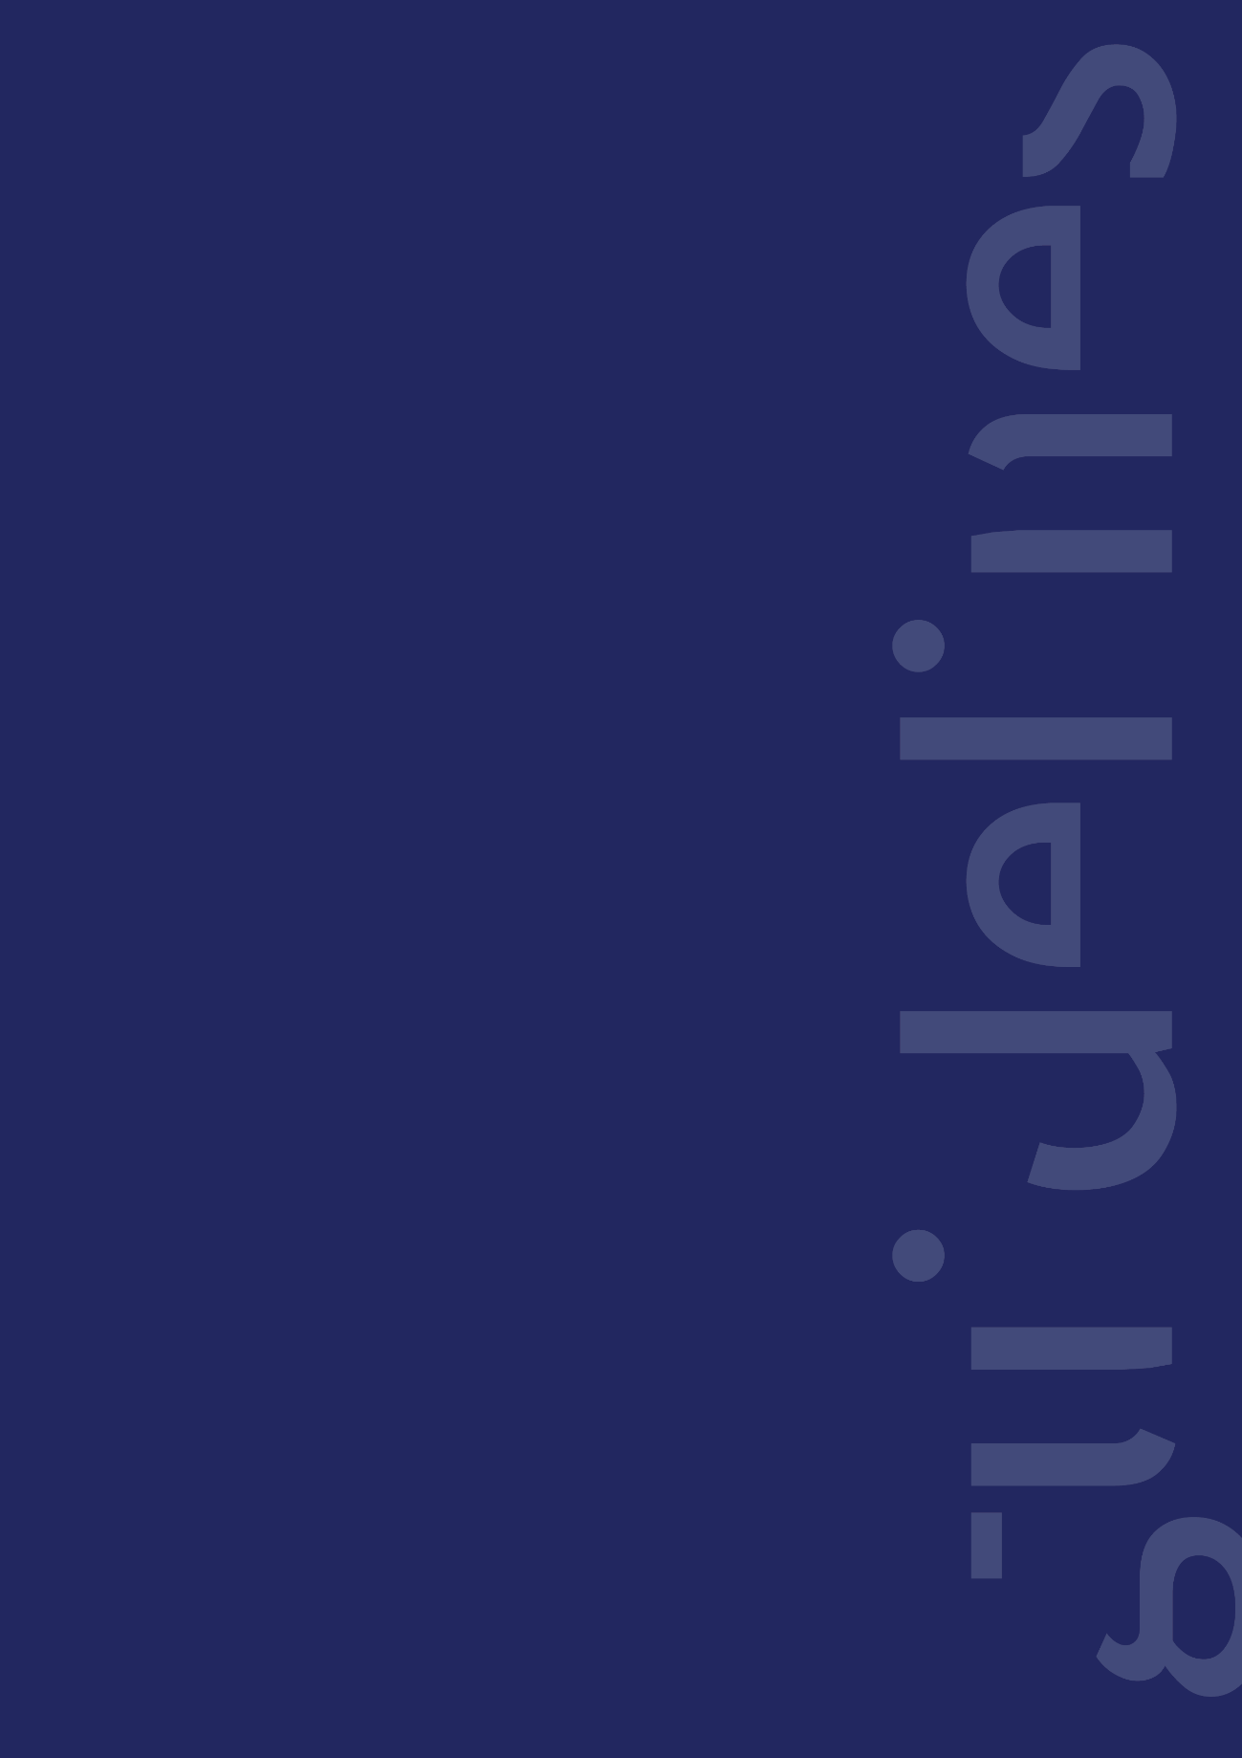The Novo Nordisk Foundation

The Novo Nordisk Foundation is an independent Danish Foundation with corporate interests. The objective of the Novo Nordisk Foundation is twofold: To provide a stable basis for the commercial and research activities conducted by the companies within the Novo Group and to support scientific and humanitarian purposes.

The vision of the Novo Nordisk Foundation is to contribute significantly to research and development that improves the lives of people and the sustainability of society.